**Database Management and Database Design- INFO 6210**

**Student Housing Management System**

**1. Problem Statement**

The Student Housing Management System is a database consisting of all the details pertaining to the dorm in a typical college setting. Off late many dorm systems are being automated by using barcode readers and databases. This project aims to reduce the manual work involved in maintaining a dorm. It deals with every connected aspect of the housing which includes- staff maintenance, food outlets in dorms, free transportation to students to the dorms from college, dorm fee payment, the buildings that comprise the dorm , the rooms and the beds and basic student information.

The advantages of using this system over manual work are as follows:

* Data redundancy can be avoided
* Analysis can be done easily by running queries
* Data can be recovered in case of some unforeseen circumstance
* Data can be modified and removed easily
* Data is consistent throughout
* Copies of data can be made and stored for safety

Sometimes partitioning the data and managing individual pieces has advantages over managing the entire big system. The individual pieces can be backed up easily as it takes less time.

**2. Business Rules**

The business rules that govern the design of this database are as follows:

1. A student can avail 0 or more utilities
2. Every student in the university need not live in a dorm
3. Each room is allotted to one student only
4. If there is a room, it should belong to a student
5. Each food outlet can belong to one building only
6. A visitor is let into only one building where the student stays
7. Each staff member is associated with one building only
8. Each building has a designated transport vehicle to the dorm buildings from the university
9. Every time someone logins into the application, an entry is made for security purposes

**3. Learning outcomes after doing the project**

1. A primary key value cannot be updated
2. A good understanding of business rules is important before forming the relationships between the entities
3. A bad database design wastes a lot of time and effort as the design has to conceptualized and re-implemented
4. The higher the normalization, the tougher it is to fetch results and bad is the performance
5. The level of normalization depends on the need. Simple queries to fetch do not need that level of normalization
6. The actual problems with the design start once you start entering data and creating definitions

**4. ER Diagram**

* Generated through Forward Engineering

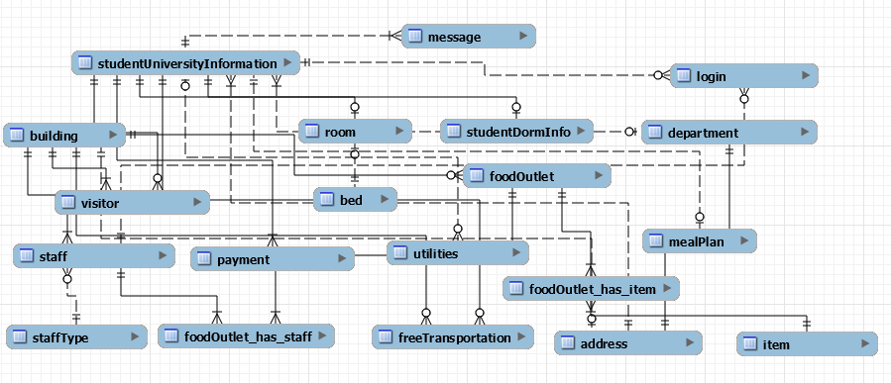

* Generated through Reverse Engineering

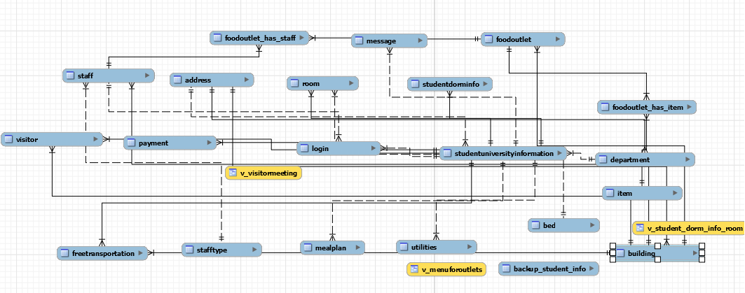

**5. Normalization**

The initial entities and attributes that I came up with after brainstorming the problem statement are as follows:

* **student-** studentId, studentName, phoneNumber, address, departmentName, departmentAddress, dateOfBirth, pointOfContactName, pointOfContactPhoneNumber, roomNumber, buildingNumber, term
* **room-** roomNumber, floorNumber, studentName, bedType, roomType, numberOfRooms, buildingName, buildingAddress
* **mealPlan-** planName, studentName, term, cost, item1, item2, item3, utilityName, utilityType
* **login-** studentId, staffId, timestamp
* **freeTransportation -** studentName, buildingName, buildingAddress
* **staff-** staffId, buildingName, buildingAddress, staffName, buildingName
* **visitor-** studentName, visitorName, visitorPhoneNumber, visitorInTime, visitorOutTime
* **department-** studentName, departmentName, departmentId, departmentAddress, studentAddress, studentPhoneNumber

There was a lot of redundancy of columns containing the same information in many tables so these tables had to be normalized to be brought into 1NF. At each stage, I realized that I needed some more attributes and tables. I had to build on my initial design.

 After normalizing them to bring them to **1NF**, the tables and their attributes were as follows:

* **student-** studentId, studentFirstName, studentLastName, phoneNumber, street, city, state, zip, departmentName, departmentStreet, departmentCity, departmentState, departmentZip, dateOfBirth, pointOfContactName, pointOfContactPhoneNumber, roomNumber, buildingNumber, term
* **room-** roomNumber, floorNumber, studentName, bedType, roomType, numberOfRooms, buildingName, buildingStreet, buildingCity, buildingState, buildingZip
* **foodPlan-** planName, studentName, term, cost, item, utilityName, utilityType, menu
* **login-** id, timestamp
* **freeTransportation-** studentName, buildingName, buildingStreet, buildingCity, buildingState, buildingZip
* **staff-** staffId, buildingName, buildingStreet, buildingCity, buildingState, buildingZip
* **visitor-** studentName, visitorFirstName, visitorLastName, visitorPhoneNumber, visitorInTime, visitorOutTime
* **department-** studentName, departmentName, departmentId, departmentStreet, departmentCity, departmentState, departmentZip, studentStreet, studentCity, studentState, studentZip, studentPhoneNumber

In each of the tables, I had just one field acting as the primary key, which meant that there was no chance of partial functional dependency. So the tables were already in 2NF as well.

But there were few transitive dependencies that I identified especially with respect to the fields in address where city was determining the state and zip code. So I had to place them in a different table.

Along the way, because of many-many relationships many bridge tables were formed.

I reduced most of the tables to 3NF barring a few as I felt that too many joins had to be made just to fetch even simple data.

The tables after removing transitive dependency are as follows:

* **studentUniversityInfo-** studentId, studentFirstName, studentLastName, phoneNumber, addressId, departmentId, pointOfContactFirstName, pointOfContactLastName, pointOfContactPhoneNumber
* **studentDormInfo-** studentId, roomNumber, buildingNumber
* **department-** departmentId, departmentName, addressId
* **login-** id, timestamp
* **visitor-** studnentId, visitorFirstName, visitorLastName, isAdult, purposeOfVisit, visitorRelationship, dateOfMeeting, dateOfExit, inTime, outTime, buildingId
* **staff-** staffId, buildingNumber, staffFirstName, staffLastName, typeId
* **staffType-** typeId, typeName
* **utilites-** utilityId, utilityType, plan, cost, studentId
* **freeTransportation-** studentId, buildingId
* **mealPlan-** planId, studentId, term
* **foodOutlet-** outletId, outletName, staffId, cost, buildingId, menuId
* **menu-** menuId, itemId
* **item-** itemName, itemId
* **payment-** paymentId, studentId, paymentDate, monthlyFees, paymentStatus, fineImposed
* **building-** buildingNumber, numberOfRooms, buildingName, addressId
* **bed-** bedId, roomNumber
* **room-** roomNumber, studentId, bedId, type
* **address-** addressId, aptNum, street, city,state, zip

The tables after adding associative entities and few other missed entities are as follows:

* **studentUniversityInfo-** studentId, studentFirstName, studentLastName, phoneNumber, addressId, departmentId, pointOfContactFirstName, pointOfContactLastName, pointOfContactPhoneNumber
* **studentDormInfo-** studentId, roomNumber, buildingNumber
* **department-** departmentId, departmentName, addressId
* **login-** id, timestamp
* **visitor-** studnentId, visitorFirstName, visitorLastName, isAdult, purposeOfVisit, visitorRelationship, dateOfMeeting, dateOfExit, inTime, outTime, buildingId
* **staff-** staffId, buildingNumber, staffFirstName, staffLastName, typeId
* **staffType-** typeId, typeName
* **utilites-** utilityId, utilityType, plan, cost, studentId
* **freeTransportation-** studentId, buildingId
* **mealPlan-** planId, studentId, term
* **foodOutlet-** outletId, outletName, staffId, cost, buildingId, menuId
* **foodOutlet_has_item-** foodOutlets_outletId, item_itemId
* **foodoutlet_has_staff-** staffInformation_staffId, foodOutlets_outletId
* **message-** stuId, message
* **item-** itemName, itemId
* **payment-** paymentId, studentId, paymentDate, monthlyFees, paymentStatus, fineImposed
* **building-** buildingNumber, numberOfRooms, buildingName, addressId
* **bed-** bedId, roomNumber
* **room-** roomNumber, studentId, bedId, type
* **address-** addressId, aptNum, street, city, state, zip

**6. Definitions**

**a. Views**

**i. View to display the food outlets along with its items and cost**

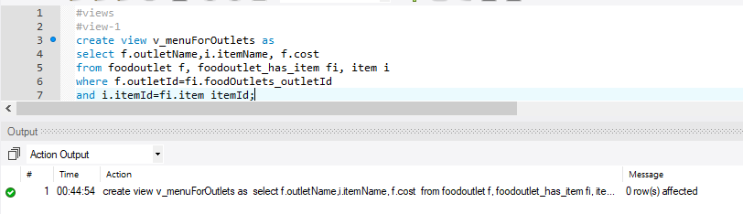

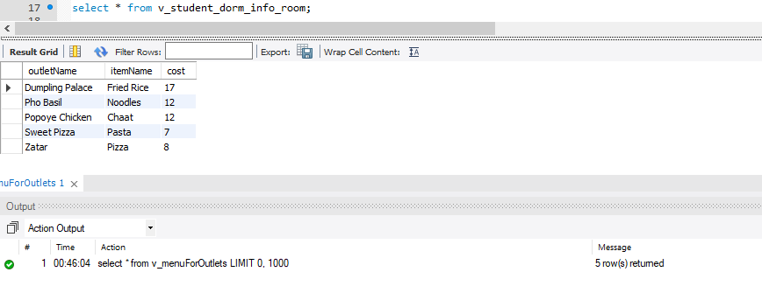

**ii. View to display the dorm information of students staying in the dorm**

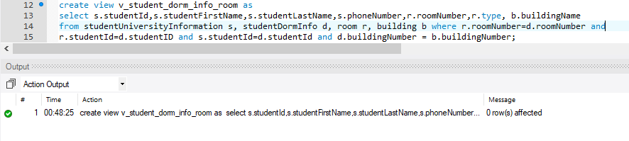

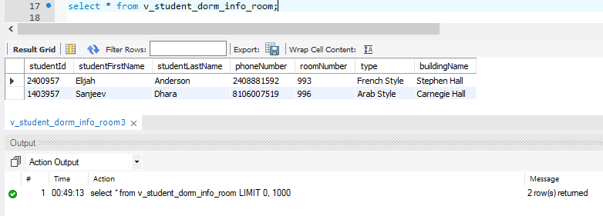

**iii. View to display the visitor information**

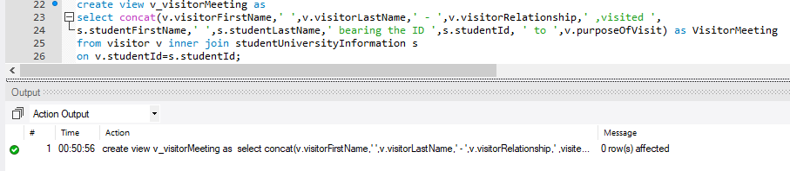

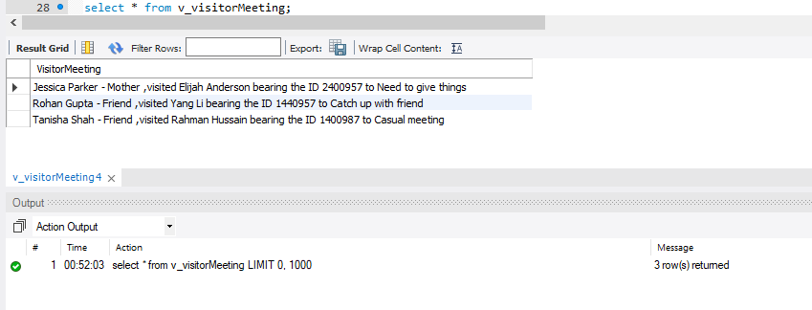

**b. Functions**

**i. Function to find out the revised cost of the utilities**

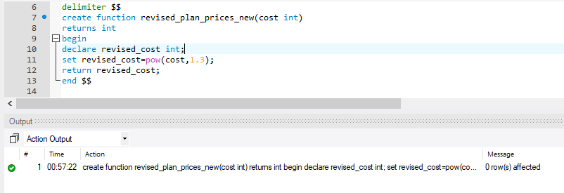

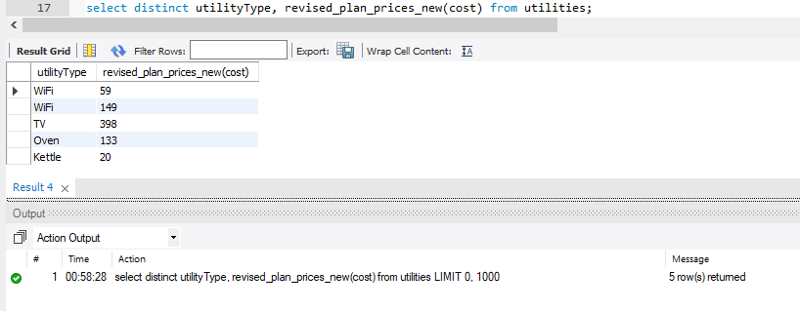

**ii. Function to calculate the increased cost of food menu items**

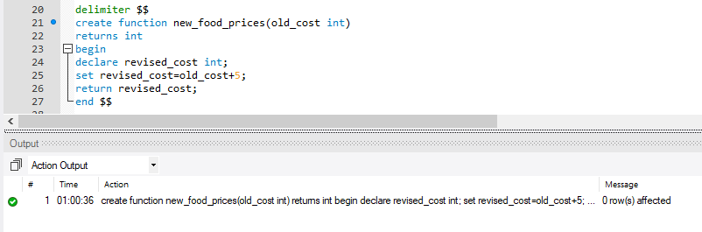

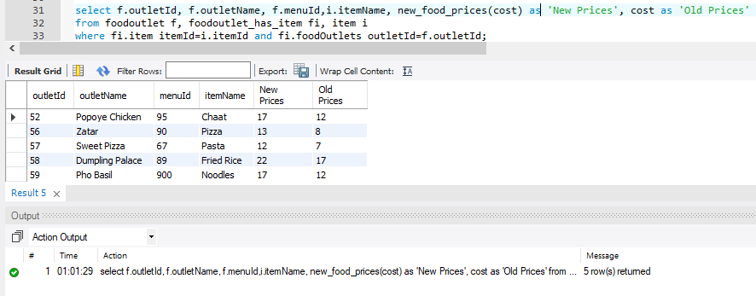

**c. Privileges**

I created 5 users and gave them access to various tables based on their roles. For example, admin would be able to access all the tables but a shuttle driver can only see the information about people boarding the shuttle.

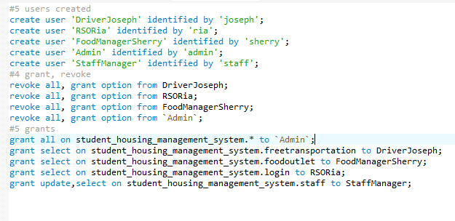

**d. Indexes**

I created few indexes on fields where I felt that more search would be performed and hence retrieval would be relatively faster.

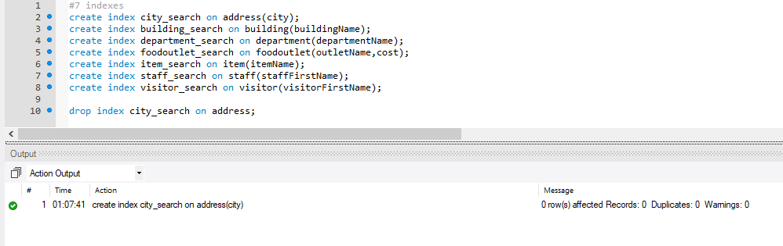

**e. Transactions**

I created 2 transactions with few sets of queries in each. I also tried out rollback and commit.

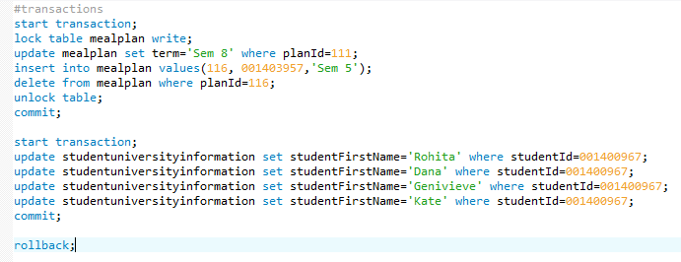

**f. Query Analyzing**

I wrote few explain statements on some tables to analyze how the query was working.

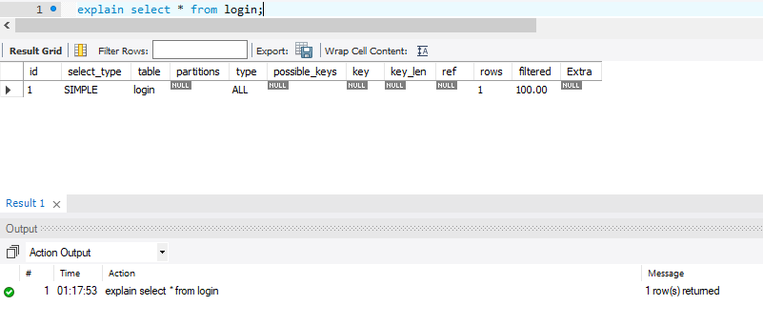

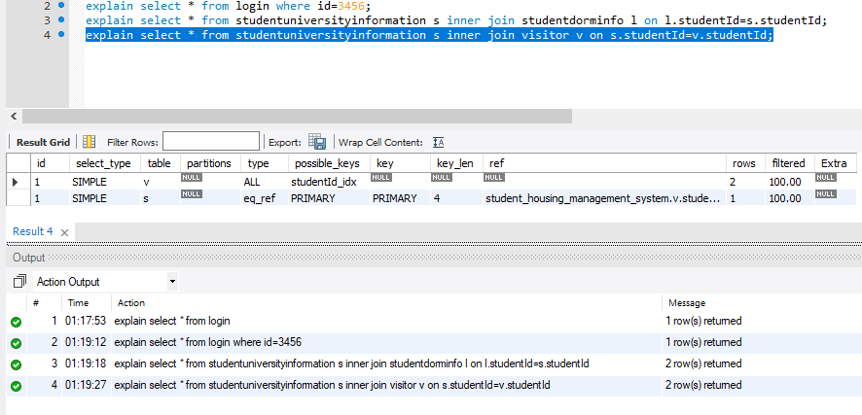

**g. Triggers**

i. Created an audit trigger to backup values of a student who leaves the university into another table

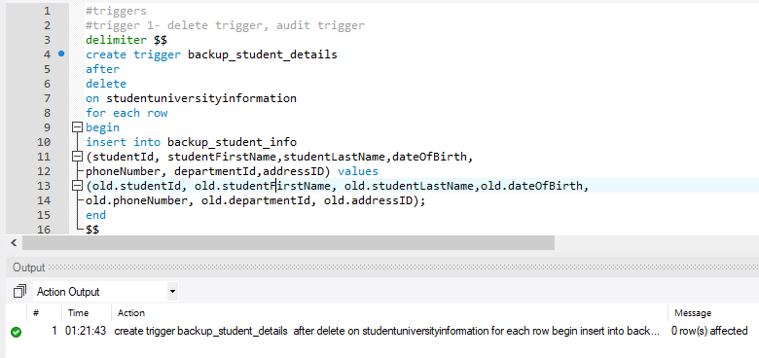

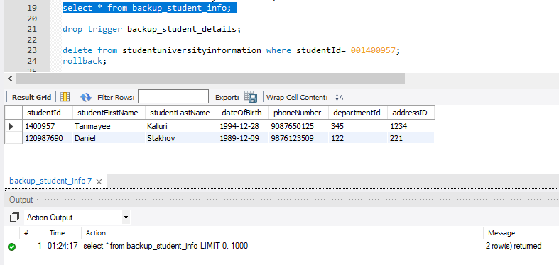

ii. Created a trigger to stamp a message into a table when a new student joins the dorm

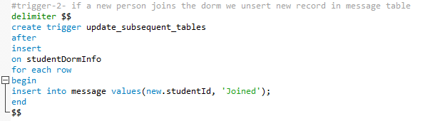

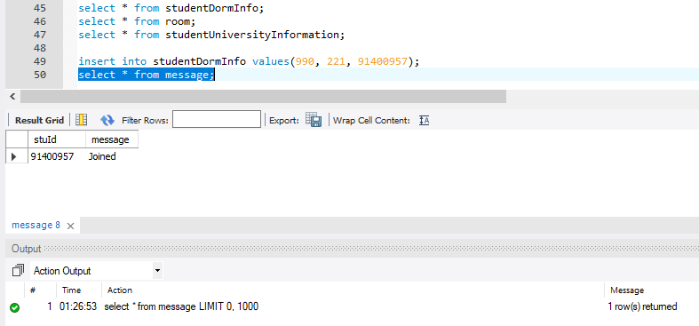

**h. Procedures**

i. Procedure to insert values into a table. We just have to pass the values as parameters to it and the insert will be performed each time. This saves a lot of time and energy as the insert statement need not be written each time.

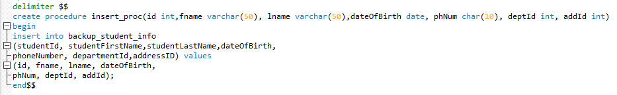

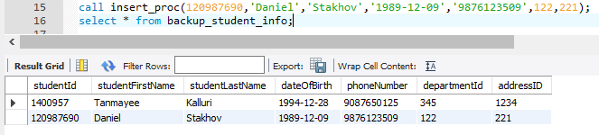

ii. Procedure to find the count of items from the items table

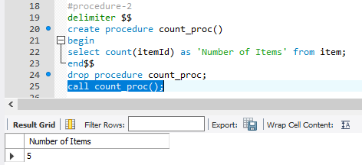

**Some analysis provided by Workbench**

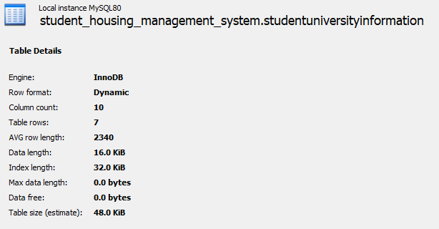

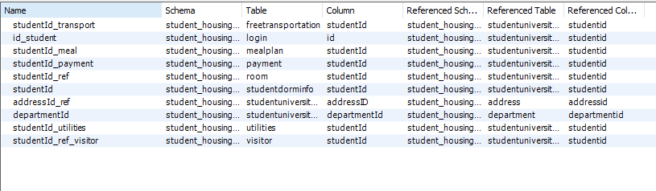

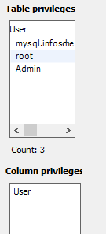

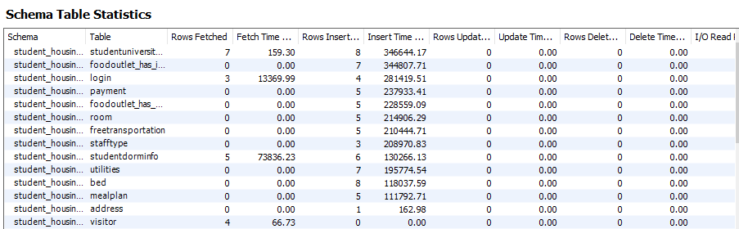

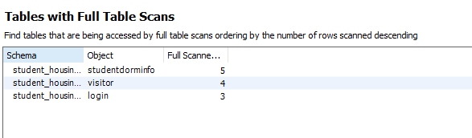

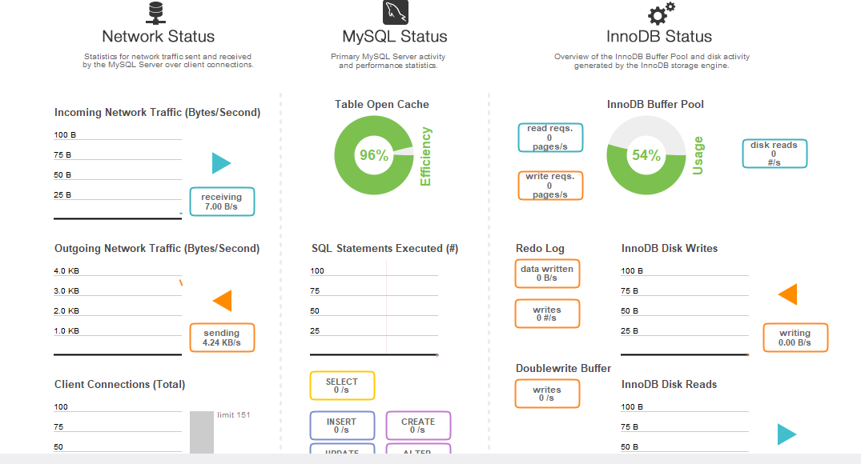

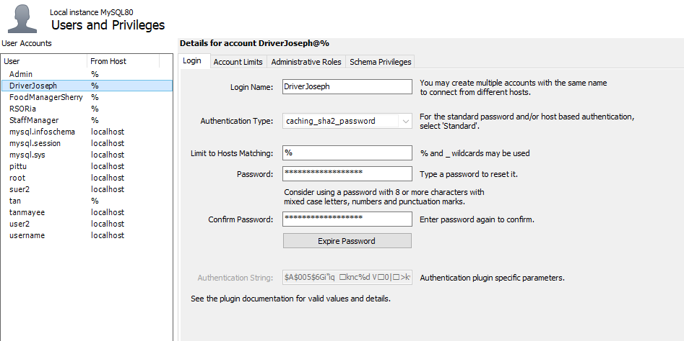

**7. Appendix**

CREATE DATABASE IF NOT EXISTS `student_housing_management_system` /*!40100 DEFAULT CHARACTER SET utf8mb4 COLLATE utf8mb4_0900_ai_ci */;

USE `student_housing_management_system`;

-- MySQL dump 10.13 Distrib 8.0.12, for Win64 (x86_64)

--

-- Host: localhost Database: student_housing_management_system

-- ------------------------------------------------------

-- Server version 8.0.12

/*!40101 SET @OLD_CHARACTER_SET_CLIENT=@@CHARACTER_SET_CLIENT */;

/*!40101 SET @OLD_CHARACTER_SET_RESULTS=@@CHARACTER_SET_RESULTS */;

/*!40101 SET @OLD_COLLATION_CONNECTION=@@COLLATION_CONNECTION */;

SET NAMES utf8 ;

/*!40103 SET @OLD_TIME_ZONE=@@TIME_ZONE */;

/*!40103 SET TIME_ZONE='+00:00' */;

/*!40014 SET @OLD_UNIQUE_CHECKS=@@UNIQUE_CHECKS, UNIQUE_CHECKS=0 */;

/*!40014 SET @OLD_FOREIGN_KEY_CHECKS=@@FOREIGN_KEY_CHECKS, FOREIGN_KEY_CHECKS=0 */;

/*!40101 SET @OLD_SQL_MODE=@@SQL_MODE, SQL_MODE='NO_AUTO_VALUE_ON_ZERO' */;

/*!40111 SET @OLD_SQL_NOTES=@@SQL_NOTES, SQL_NOTES=0 */;

--

-- Table structure for table `address`

--

DROP TABLE IF EXISTS `address`;

/*!40101 SET @saved_cs_client = @@character_set_client */;

SET character_set_client = utf8mb4 ;

CREATE TABLE `address` (

`aptNum` int(11) DEFAULT NULL,

`streetName` varchar(50) DEFAULT NULL,

`city` varchar(50) DEFAULT NULL,

`state` varchar(50) DEFAULT NULL,

`zip` char(5) DEFAULT NULL,

`addressId` int(11) NOT NULL,

PRIMARY KEY (`addressId`),

KEY `city_search` (`city`)

) ENGINE=InnoDB DEFAULT CHARSET=utf8mb4 COLLATE=utf8mb4_0900_ai_ci;

/*!40101 SET character_set_client = @saved_cs_client */;

--

-- Dumping data for table `address`

--

LOCK TABLES `address` WRITE;

/*!40000 ALTER TABLE `address` DISABLE KEYS */;

INSERT INTO `address` VALUES (63,'St Germain','Boston','MA','2115',120),(12,'Peterborough','Brighton','MA','2135',121),(677,'Devon','Malden','MA','2755',122),(98,'Warren Street','Allston','MA','2095',123),(78,'Causeway Street','Cambridge','MA','2167',124),(2,'Anne Street','Boston','MA','2115',221),(62,'Clearway Street','Boston','MA','2115',1234);

/*!40000 ALTER TABLE `address` ENABLE KEYS */;

UNLOCK TABLES;

--

-- Table structure for table `backup_student_info`

--

DROP TABLE IF EXISTS `backup_student_info`;

/*!40101 SET @saved_cs_client = @@character_set_client */;

SET character_set_client = utf8mb4 ;

CREATE TABLE `backup_student_info` (

`studentId` int(11) DEFAULT NULL,

`studentFirstName` varchar(50) DEFAULT NULL,

`studentLastName` varchar(50) DEFAULT NULL,

`dateOfBirth` date DEFAULT NULL,

`phoneNumber` char(10) DEFAULT NULL,

`departmentId` int(11) DEFAULT NULL,

`addressID` int(11) DEFAULT NULL

) ENGINE=InnoDB DEFAULT CHARSET=utf8mb4 COLLATE=utf8mb4_0900_ai_ci;

/*!40101 SET character_set_client = @saved_cs_client */;

--

-- Dumping data for table `backup_student_info`

--

LOCK TABLES `backup_student_info` WRITE;

/*!40000 ALTER TABLE `backup_student_info` DISABLE KEYS */;

INSERT INTO `backup_student_info` VALUES (1400957,'Tanmayee','Kalluri','1994-12-28','9087650125',345,1234),(120987690,'Daniel','Stakhov','1989-12-09','9876123509',122,221);

/*!40000 ALTER TABLE `backup_student_info` ENABLE KEYS */;

UNLOCK TABLES;

--

-- Table structure for table `bed`

--

DROP TABLE IF EXISTS `bed`;

/*!40101 SET @saved_cs_client = @@character_set_client */;

SET character_set_client = utf8mb4 ;

CREATE TABLE `bed` (

`bedId` int(11) NOT NULL,

`roomNumber` int(11) DEFAULT NULL,

PRIMARY KEY (`bedId`)

) ENGINE=InnoDB DEFAULT CHARSET=utf8mb4 COLLATE=utf8mb4_0900_ai_ci;

/*!40101 SET character_set_client = @saved_cs_client */;

--

-- Dumping data for table `bed`

--

LOCK TABLES `bed` WRITE;

/*!40000 ALTER TABLE `bed` DISABLE KEYS */;

INSERT INTO `bed` VALUES (1,100),(2,101),(3,102),(4,103),(5,104);

/*!40000 ALTER TABLE `bed` ENABLE KEYS */;

UNLOCK TABLES;

--

-- Table structure for table `building`

--

DROP TABLE IF EXISTS `building`;

/*!40101 SET @saved_cs_client = @@character_set_client */;

SET character_set_client = utf8mb4 ;

CREATE TABLE `building` (

`buildingNumber` int(11) NOT NULL,

`numberOfRooms` int(11) DEFAULT NULL,

`buildingName` varchar(50) DEFAULT NULL,

`addressId` int(11) NOT NULL,

PRIMARY KEY (`buildingNumber`,`addressId`),

KEY `addressId_idx` (`addressId`),

KEY `building_search` (`buildingName`),

CONSTRAINT `addressId_building` FOREIGN KEY (`addressId`) REFERENCES `address` (`addressid`)

) ENGINE=InnoDB DEFAULT CHARSET=utf8mb4 COLLATE=utf8mb4_0900_ai_ci;

/*!40101 SET character_set_client = @saved_cs_client */;

--

-- Dumping data for table `building`

--

LOCK TABLES `building` WRITE;

/*!40000 ALTER TABLE `building` DISABLE KEYS */;

INSERT INTO `building` VALUES (220,30,'Speare Hall',120),(221,10,'Stetson Hall',120),(222,5,'Stephen Hall',121),(223,20,'Carnegie Hall',124),(224,70,'Snell Hall',123);

/*!40000 ALTER TABLE `building` ENABLE KEYS */;

UNLOCK TABLES;

--

-- Table structure for table `department`

--

DROP TABLE IF EXISTS `department`;

/*!40101 SET @saved_cs_client = @@character_set_client */;

SET character_set_client = utf8mb4 ;

CREATE TABLE `department` (

`departmentId` int(11) NOT NULL,

`departmentName` varchar(50) DEFAULT NULL,

`addressId` int(11) NOT NULL,

PRIMARY KEY (`departmentId`,`addressId`),

KEY `addressId_idx` (`addressId`),

KEY `department_search` (`departmentName`),

CONSTRAINT `addressId` FOREIGN KEY (`addressId`) REFERENCES `address` (`addressid`)

) ENGINE=InnoDB DEFAULT CHARSET=utf8mb4 COLLATE=utf8mb4_0900_ai_ci;

/*!40101 SET character_set_client = @saved_cs_client */;

--

-- Dumping data for table `department`

--

LOCK TABLES `department` WRITE;

/*!40000 ALTER TABLE `department` DISABLE KEYS */;

INSERT INTO `department` VALUES (348,'College of Arts',120),(345,'College of Engineering',122),(346,'College of Health Sciences',121),(343,'College of Science',124),(344,'College of Science',124),(344,'Law College',121);

/*!40000 ALTER TABLE `department` ENABLE KEYS */;

UNLOCK TABLES;

--

-- Table structure for table `foodoutlet`

--

DROP TABLE IF EXISTS `foodoutlet`;

/*!40101 SET @saved_cs_client = @@character_set_client */;

SET character_set_client = utf8mb4 ;

CREATE TABLE `foodoutlet` (

`outletId` int(11) NOT NULL,

`outletName` varchar(45) DEFAULT NULL,

`menuId` int(11) DEFAULT NULL,

`cost` int(11) DEFAULT NULL,

`buildingId` int(11) NOT NULL,

PRIMARY KEY (`outletId`,`buildingId`),

KEY `buildingNumber_idx` (`buildingId`),

KEY `foodoutlet_search` (`outletName`,`cost`),

CONSTRAINT `buildingNumber_food` FOREIGN KEY (`buildingId`) REFERENCES `building` (`buildingnumber`)

) ENGINE=InnoDB DEFAULT CHARSET=utf8mb4 COLLATE=utf8mb4_0900_ai_ci;

/*!40101 SET character_set_client = @saved_cs_client */;

--

-- Dumping data for table `foodoutlet`

--

LOCK TABLES `foodoutlet` WRITE;

/*!40000 ALTER TABLE `foodoutlet` DISABLE KEYS */;

INSERT INTO `foodoutlet` VALUES (52,'Popoye Chicken',95,12,220),(56,'Zatar',90,8,221),(57,'Sweet Pizza',67,7,222),(58,'Dumpling Palace',89,17,223),(59,'Pho Basil',900,12,221);

/*!40000 ALTER TABLE `foodoutlet` ENABLE KEYS */;

UNLOCK TABLES;

--

-- Table structure for table `foodoutlet_has_item`

--

DROP TABLE IF EXISTS `foodoutlet_has_item`;

/*!40101 SET @saved_cs_client = @@character_set_client */;

SET character_set_client = utf8mb4 ;

CREATE TABLE `foodoutlet_has_item` (

`foodOutlets_outletId` int(11) NOT NULL,

`item_itemId` int(11) NOT NULL,

PRIMARY KEY (`foodOutlets_outletId`,`item_itemId`),

KEY `fk_foodOutlets_has_item_item1_idx` (`item_itemId`),

KEY `fk_foodOutlets_has_item_foodOutlets1_idx` (`foodOutlets_outletId`),

CONSTRAINT `fk_foodOutlets_has_item_foodOutlets1` FOREIGN KEY (`foodOutlets_outletId`) REFERENCES `foodoutlet` (`outletid`),

CONSTRAINT `fk_foodOutlets_has_item_item1` FOREIGN KEY (`item_itemId`) REFERENCES `item` (`itemid`)

) ENGINE=InnoDB DEFAULT CHARSET=utf8mb4 COLLATE=utf8mb4_0900_ai_ci;

/*!40101 SET character_set_client = @saved_cs_client */;

--

-- Dumping data for table `foodoutlet_has_item`

--

LOCK TABLES `foodoutlet_has_item` WRITE;

/*!40000 ALTER TABLE `foodoutlet_has_item` DISABLE KEYS */;

INSERT INTO `foodoutlet_has_item` VALUES (56,12),(57,13),(58,14),(59,15),(52,16);

/*!40000 ALTER TABLE `foodoutlet_has_item` ENABLE KEYS */;

UNLOCK TABLES;

--

-- Table structure for table `foodoutlet_has_staff`

--

DROP TABLE IF EXISTS `foodoutlet_has_staff`;

/*!40101 SET @saved_cs_client = @@character_set_client */;

SET character_set_client = utf8mb4 ;

CREATE TABLE `foodoutlet_has_staff` (

`foodOutlets_outletId` int(11) NOT NULL,

`staffInformation_staffId` int(11) NOT NULL,

PRIMARY KEY (`foodOutlets_outletId`,`staffInformation_staffId`),

KEY `fk_foodOutlets_has_staffInformation_staffInformation1_idx` (`staffInformation_staffId`),

KEY `fk_foodOutlets_has_staffInformation_foodOutlets1_idx` (`foodOutlets_outletId`),

CONSTRAINT `fk_foodOutlets_has_staffInformation_foodOutlets1` FOREIGN KEY (`foodOutlets_outletId`) REFERENCES `foodoutlet` (`outletid`),

CONSTRAINT `fk_foodOutlets_has_staffInformation_staffInformation1` FOREIGN KEY (`staffInformation_staffId`) REFERENCES `staff` (`staffid`)

) ENGINE=InnoDB DEFAULT CHARSET=utf8mb4 COLLATE=utf8mb4_0900_ai_ci;

/*!40101 SET character_set_client = @saved_cs_client */;

--

-- Dumping data for table `foodoutlet_has_staff`

--

LOCK TABLES `foodoutlet_has_staff` WRITE;

/*!40000 ALTER TABLE `foodoutlet_has_staff` DISABLE KEYS */;

INSERT INTO `foodoutlet_has_staff` VALUES (52,3450),(56,3456),(57,3457),(58,3458),(59,3459);

/*!40000 ALTER TABLE `foodoutlet_has_staff` ENABLE KEYS */;

UNLOCK TABLES;

--

-- Table structure for table `freetransportation`

--

DROP TABLE IF EXISTS `freetransportation`;

/*!40101 SET @saved_cs_client = @@character_set_client */;

SET character_set_client = utf8mb4 ;

CREATE TABLE `freetransportation` (

`studentId` int(11) NOT NULL,

`dropLocation` int(11) NOT NULL,

PRIMARY KEY (`studentId`,`dropLocation`),

KEY `dropLoc_idx` (`dropLocation`),

CONSTRAINT `dropLoc` FOREIGN KEY (`dropLocation`) REFERENCES `building` (`buildingnumber`),

CONSTRAINT `studentId_transport` FOREIGN KEY (`studentId`) REFERENCES `studentuniversityinformation` (`studentid`)

) ENGINE=InnoDB DEFAULT CHARSET=utf8mb4 COLLATE=utf8mb4_0900_ai_ci;

/*!40101 SET character_set_client = @saved_cs_client */;

--

-- Dumping data for table `freetransportation`

--

LOCK TABLES `freetransportation` WRITE;

/*!40000 ALTER TABLE `freetransportation` DISABLE KEYS */;

INSERT INTO `freetransportation` VALUES (1400987,220),(2400957,221),(1403957,222),(1400967,223),(1440957,224);

/*!40000 ALTER TABLE `freetransportation` ENABLE KEYS */;

UNLOCK TABLES;

--

-- Table structure for table `item`

--

DROP TABLE IF EXISTS `item`;

/*!40101 SET @saved_cs_client = @@character_set_client */;

SET character_set_client = utf8mb4 ;

CREATE TABLE `item` (

`itemId` int(11) NOT NULL,

`itemName` varchar(45) DEFAULT NULL,

PRIMARY KEY (`itemId`),

KEY `item_search` (`itemName`)

) ENGINE=InnoDB DEFAULT CHARSET=utf8mb4 COLLATE=utf8mb4_0900_ai_ci;

/*!40101 SET character_set_client = @saved_cs_client */;

--

-- Dumping data for table `item`

--

LOCK TABLES `item` WRITE;

/*!40000 ALTER TABLE `item` DISABLE KEYS */;

INSERT INTO `item` VALUES (16,'Chaat'),(14,'Fried Rice'),(15,'Noodles'),(13,'Pasta'),(12,'Pizza');

/*!40000 ALTER TABLE `item` ENABLE KEYS */;

UNLOCK TABLES;

--

-- Table structure for table `login`

--

DROP TABLE IF EXISTS `login`;

/*!40101 SET @saved_cs_client = @@character_set_client */;

SET character_set_client = utf8mb4 ;

CREATE TABLE `login` (

`id` int(11) NOT NULL,

`timestamp` timestamp(6) NULL DEFAULT NULL,

KEY `id_student` (`id`),

CONSTRAINT `id_staff` FOREIGN KEY (`id`) REFERENCES `staff` (`staffid`),

CONSTRAINT `id_student` FOREIGN KEY (`id`) REFERENCES `studentuniversityinformation` (`studentid`)

) ENGINE=InnoDB DEFAULT CHARSET=utf8mb4 COLLATE=utf8mb4_0900_ai_ci;

/*!40101 SET character_set_client = @saved_cs_client */;

--

-- Dumping data for table `login`

--

LOCK TABLES `login` WRITE;

/*!40000 ALTER TABLE `login` DISABLE KEYS */;

/*!40000 ALTER TABLE `login` ENABLE KEYS */;

UNLOCK TABLES;

--

-- Table structure for table `mealplan`

--

DROP TABLE IF EXISTS `mealplan`;

/*!40101 SET @saved_cs_client = @@character_set_client */;

SET character_set_client = utf8mb4 ;

CREATE TABLE `mealplan` (

`planId` int(11) NOT NULL,

`studentId` int(11) DEFAULT NULL,

`term` varchar(45) DEFAULT NULL,

PRIMARY KEY (`planId`),

KEY `studentId_idx` (`studentId`),

CONSTRAINT `studentId_meal` FOREIGN KEY (`studentId`) REFERENCES `studentuniversityinformation` (`studentid`)

) ENGINE=InnoDB DEFAULT CHARSET=utf8mb4 COLLATE=utf8mb4_0900_ai_ci;

/*!40101 SET character_set_client = @saved_cs_client */;

--

-- Dumping data for table `mealplan`

--

LOCK TABLES `mealplan` WRITE;

/*!40000 ALTER TABLE `mealplan` DISABLE KEYS */;

INSERT INTO `mealplan` VALUES (111,1440957,'Sem 8'),(112,1400967,'Sem 1'),(113,1403957,'Sem 2'),(114,2400957,'Sem 4'),(115,1400987,'Sem 8');

/*!40000 ALTER TABLE `mealplan` ENABLE KEYS */;

UNLOCK TABLES;

--

-- Table structure for table `message`

--

DROP TABLE IF EXISTS `message`;

/*!40101 SET @saved_cs_client = @@character_set_client */;

SET character_set_client = utf8mb4 ;

CREATE TABLE `message` (

`stuId` int(11) DEFAULT NULL,

`message` varchar(20) DEFAULT NULL,

KEY `studentId_key_idx` (`stuId`),

CONSTRAINT `studentId_key` FOREIGN KEY (`stuId`) REFERENCES `studentuniversityinformation` (`studentid`)

) ENGINE=InnoDB DEFAULT CHARSET=utf8mb4 COLLATE=utf8mb4_0900_ai_ci;

/*!40101 SET character_set_client = @saved_cs_client */;

--

-- Dumping data for table `message`

--

LOCK TABLES `message` WRITE;

/*!40000 ALTER TABLE `message` DISABLE KEYS */;

INSERT INTO `message` VALUES (91400957,'Joined');

/*!40000 ALTER TABLE `message` ENABLE KEYS */;

UNLOCK TABLES;

--

-- Table structure for table `payment`

--

DROP TABLE IF EXISTS `payment`;

/*!40101 SET @saved_cs_client = @@character_set_client */;

SET character_set_client = utf8mb4 ;

CREATE TABLE `payment` (

`paymentId` int(11) NOT NULL,

`studentId` int(11) NOT NULL,

`paymentDate` date DEFAULT NULL,

`monthlyFees` decimal(4,0) DEFAULT NULL,

`paymentStatus` varchar(45) DEFAULT NULL,

`fineImposed` decimal(4,0) DEFAULT NULL,

PRIMARY KEY (`paymentId`,`studentId`),

KEY `studentId_idx` (`studentId`),

CONSTRAINT `studentId_payment` FOREIGN KEY (`studentId`) REFERENCES `studentuniversityinformation` (`studentid`)

) ENGINE=InnoDB DEFAULT CHARSET=utf8mb4 COLLATE=utf8mb4_0900_ai_ci;

/*!40101 SET character_set_client = @saved_cs_client */;

--

-- Dumping data for table `payment`

--

LOCK TABLES `payment` WRITE;

/*!40000 ALTER TABLE `payment` DISABLE KEYS */;

INSERT INTO `payment` VALUES (90001,1400987,'2017-09-27',1300,'Paid',0),(90002,2400957,'2018-09-27',800,'Late payment',20),(90003,1403957,'2016-08-23',1200,'Late',34),(90004,1400967,'2017-12-12',600,'Paid',0),(90005,1440957,'2018-11-20',500,'Paid',0);

/*!40000 ALTER TABLE `payment` ENABLE KEYS */;

UNLOCK TABLES;

--

-- Table structure for table `room`

--

DROP TABLE IF EXISTS `room`;

/*!40101 SET @saved_cs_client = @@character_set_client */;

SET character_set_client = utf8mb4 ;

CREATE TABLE `room` (

`roomNumber` int(11) NOT NULL,

`studentId` int(11) NOT NULL,

`bedId` int(11) DEFAULT NULL,

`type` varchar(20) DEFAULT NULL,

PRIMARY KEY (`roomNumber`,`studentId`),

KEY `studentId_idx` (`studentId`),

KEY `bedId_idx` (`bedId`),

CONSTRAINT `bedId` FOREIGN KEY (`bedId`) REFERENCES `bed` (`bedid`),

CONSTRAINT `studentId_ref` FOREIGN KEY (`studentId`) REFERENCES `studentuniversityinformation` (`studentid`)

) ENGINE=InnoDB DEFAULT CHARSET=utf8mb4 COLLATE=utf8mb4_0900_ai_ci;

/*!40101 SET character_set_client = @saved_cs_client */;

--

-- Dumping data for table `room`

--

LOCK TABLES `room` WRITE;

/*!40000 ALTER TABLE `room` DISABLE KEYS */;

INSERT INTO `room` VALUES (990,1400967,4,'Italian Style'),(991,1440957,5,'Persian Style'),(993,2400957,2,'French Style'),(996,1403957,3,'Arab Style'),(999,1400987,1,'Italian Style');

/*!40000 ALTER TABLE `room` ENABLE KEYS */;

UNLOCK TABLES;

--

-- Table structure for table `staff`

--

DROP TABLE IF EXISTS `staff`;

/*!40101 SET @saved_cs_client = @@character_set_client */;

SET character_set_client = utf8mb4 ;

CREATE TABLE `staff` (

`staffId` int(11) NOT NULL,

`buildingNumber` int(11) NOT NULL,

`staffFirstName` varchar(90) DEFAULT NULL,

`staffLastName` varchar(45) DEFAULT NULL,

`typeId` int(11) DEFAULT NULL,

PRIMARY KEY (`staffId`,`buildingNumber`),

KEY `buildingNumber_idx` (`buildingNumber`),

KEY `typeID_idx` (`typeId`),

KEY `staff_search` (`staffFirstName`),

CONSTRAINT `buildingNumber` FOREIGN KEY (`buildingNumber`) REFERENCES `building` (`buildingnumber`),

CONSTRAINT `typeID` FOREIGN KEY (`typeId`) REFERENCES `stafftype` (`typeid`)

) ENGINE=InnoDB DEFAULT CHARSET=utf8mb4 COLLATE=utf8mb4_0900_ai_ci;

/*!40101 SET character_set_client = @saved_cs_client */;

--

-- Dumping data for table `staff`

--

LOCK TABLES `staff` WRITE;

/*!40000 ALTER TABLE `staff` DISABLE KEYS */;

INSERT INTO `staff` VALUES (3450,224,'Lin','Dan',892),(3453,220,'Rafael','Nadal',892),(3456,220,'Melissa','George',890),(3457,221,'Sidharth','Pati',890),(3458,222,'Padma','Priya',890),(3459,223,'Nikhil','Narla',891);

/*!40000 ALTER TABLE `staff` ENABLE KEYS */;

UNLOCK TABLES;

--

-- Table structure for table `stafftype`

--

DROP TABLE IF EXISTS `stafftype`;

/*!40101 SET @saved_cs_client = @@character_set_client */;

SET character_set_client = utf8mb4 ;

CREATE TABLE `stafftype` (

`typeId` int(11) NOT NULL,

`typeName` varchar(45) DEFAULT NULL,

PRIMARY KEY (`typeId`)

) ENGINE=InnoDB DEFAULT CHARSET=utf8mb4 COLLATE=utf8mb4_0900_ai_ci;

/*!40101 SET character_set_client = @saved_cs_client */;

--

-- Dumping data for table `stafftype`

--

LOCK TABLES `stafftype` WRITE;

/*!40000 ALTER TABLE `stafftype` DISABLE KEYS */;

INSERT INTO `stafftype` VALUES (890,'Food Outlet Staff'),(891,'Maintenence Staff'),(892,'Security Staff');

/*!40000 ALTER TABLE `stafftype` ENABLE KEYS */;

UNLOCK TABLES;

--

-- Table structure for table `studentdorminfo`

--

DROP TABLE IF EXISTS `studentdorminfo`;

/*!40101 SET @saved_cs_client = @@character_set_client */;

SET character_set_client = utf8mb4 ;

CREATE TABLE `studentdorminfo` (

`roomNumber` int(11) DEFAULT NULL,

`buildingNumber` int(11) DEFAULT NULL,

`studentId` int(11) NOT NULL,

PRIMARY KEY (`studentId`),

KEY `studentId_idx` (`studentId`),

CONSTRAINT `studentId` FOREIGN KEY (`studentId`) REFERENCES `studentuniversityinformation` (`studentid`)

) ENGINE=InnoDB DEFAULT CHARSET=utf8mb4 COLLATE=utf8mb4_0900_ai_ci;

/*!40101 SET character_set_client = @saved_cs_client */;

--

-- Dumping data for table `studentdorminfo`

--

LOCK TABLES `studentdorminfo` WRITE;

/*!40000 ALTER TABLE `studentdorminfo` DISABLE KEYS */;

INSERT INTO `studentdorminfo` VALUES (991,220,1400967),(996,223,1403957),(999,224,1440957),(993,222,2400957),(990,221,91400957);

/*!40000 ALTER TABLE `studentdorminfo` ENABLE KEYS */;

UNLOCK TABLES;

/*!50003 SET @saved_cs_client = @@character_set_client */ ;

/*!50003 SET @saved_cs_results = @@character_set_results */ ;

/*!50003 SET @saved_col_connection = @@collation_connection */ ;

/*!50003 SET character_set_client = utf8mb4 */ ;

/*!50003 SET character_set_results = utf8mb4 */ ;

/*!50003 SET collation_connection = utf8mb4_0900_ai_ci */ ;

/*!50003 SET @saved_sql_mode = @@sql_mode */ ;

/*!50003 SET sql_mode = 'STRICT_TRANS_TABLES,NO_ENGINE_SUBSTITUTION' */ ;

DELIMITER ;;

/*!50003 CREATE*/ /*!50017 DEFINER=`root`@`localhost`*/ /*!50003 TRIGGER `update_subsequent_tables` AFTER INSERT ON `studentdorminfo` FOR EACH ROW begin

insert into message values(new.studentId, 'Joined');

end */;;

DELIMITER ;

/*!50003 SET sql_mode = @saved_sql_mode */ ;

/*!50003 SET character_set_client = @saved_cs_client */ ;

/*!50003 SET character_set_results = @saved_cs_results */ ;

/*!50003 SET collation_connection = @saved_col_connection */ ;

--

-- Table structure for table `studentuniversityinformation`

--

DROP TABLE IF EXISTS `studentuniversityinformation`;

/*!40101 SET @saved_cs_client = @@character_set_client */;

SET character_set_client = utf8mb4 ;

CREATE TABLE `studentuniversityinformation` (

`studentId` int(11) NOT NULL,

`studentFirstName` varchar(50) DEFAULT NULL,

`studentLastName` varchar(50) DEFAULT NULL,

`dateOfBirth` date DEFAULT NULL,

`phoneNumber` char(10) DEFAULT NULL,

`pointOfContactFirstName` varchar(50) DEFAULT NULL,

`pointOfContactLastName` varchar(50) DEFAULT NULL,

`pointOfContactNumber` char(10) DEFAULT NULL,

`departmentId` int(11) DEFAULT NULL,

`addressID` int(11) DEFAULT NULL,

PRIMARY KEY (`studentId`),

KEY `departmentId_idx` (`departmentId`),

KEY `addressId_idx` (`addressID`),

CONSTRAINT `addressId_ref` FOREIGN KEY (`addressID`) REFERENCES `address` (`addressid`),

CONSTRAINT `departmentId` FOREIGN KEY (`departmentId`) REFERENCES `department` (`departmentid`) ON DELETE CASCADE ON UPDATE CASCADE

) ENGINE=InnoDB DEFAULT CHARSET=utf8mb4 COLLATE=utf8mb4_0900_ai_ci;

/*!40101 SET character_set_client = @saved_cs_client */;

--

-- Dumping data for table `studentuniversityinformation`

--

LOCK TABLES `studentuniversityinformation` WRITE;

/*!40000 ALTER TABLE `studentuniversityinformation` DISABLE KEYS */;

INSERT INTO `studentuniversityinformation` VALUES (1400957,'Tanmayee','Kalluri','1994-12-28','9087650125','Shobha','Murthy','9945283680',345,1234),(1400967,'Kate','Dhara','1999-11-08','9945890128','Swagatika','Dash','9945283680',346,1234),(1400987,'Rahman','Hussain','2000-04-15','8176175634','Farhat','Ali',NULL,344,121),(1403957,'Sanjeev','Dhara','1992-02-28','8106007519','Srinivas','Dhara','9945283680',345,124),(1440957,'Yang','Li','2000-12-28','9492034232','Shia','Li','9440921265',343,1234),(2400957,'Elijah','Anderson','2000-09-04','2408881592','Matt','Anderson',NULL,344,123),(91400957,'Amrutha','Malladi','1995-07-18','9700072011','Jawahar','Malladi','9945283680',348,121);

/*!40000 ALTER TABLE `studentuniversityinformation` ENABLE KEYS */;

UNLOCK TABLES;

/*!50003 SET @saved_cs_client = @@character_set_client */ ;

/*!50003 SET @saved_cs_results = @@character_set_results */ ;

/*!50003 SET @saved_col_connection = @@collation_connection */ ;

/*!50003 SET character_set_client = utf8mb4 */ ;

/*!50003 SET character_set_results = utf8mb4 */ ;

/*!50003 SET collation_connection = utf8mb4_0900_ai_ci */ ;

/*!50003 SET @saved_sql_mode = @@sql_mode */ ;

/*!50003 SET sql_mode = 'STRICT_TRANS_TABLES,NO_ENGINE_SUBSTITUTION' */ ;

DELIMITER ;;

/*!50003 CREATE*/ /*!50017 DEFINER=`root`@`localhost`*/ /*!50003 TRIGGER `backup_student_details` AFTER DELETE ON `studentuniversityinformation` FOR EACH ROW begin

insert into backup_student_info

(studentId, studentFirstName,studentLastName,dateOfBirth,

phoneNumber, departmentId,addressID) values

(old.studentId, old.studentFirstName, old.studentLastName,old.dateOfBirth,

old.phoneNumber, old.departmentId, old.addressID);

end */;;

DELIMITER ;

/*!50003 SET sql_mode = @saved_sql_mode */ ;

/*!50003 SET character_set_client = @saved_cs_client */ ;

/*!50003 SET character_set_results = @saved_cs_results */ ;

/*!50003 SET collation_connection = @saved_col_connection */ ;

--

-- Table structure for table `utilities`

--

DROP TABLE IF EXISTS `utilities`;

/*!40101 SET @saved_cs_client = @@character_set_client */;

SET character_set_client = utf8mb4 ;

CREATE TABLE `utilities` (

`utilityId` int(11) NOT NULL,

`utilityType` varchar(45) DEFAULT NULL,

`plan` varchar(45) DEFAULT NULL,

`cost` decimal(4,0) DEFAULT NULL,

`studentId` int(11) DEFAULT NULL,

PRIMARY KEY (`utilityId`),

KEY `studentId_idx` (`studentId`),

CONSTRAINT `studentId_utilities` FOREIGN KEY (`studentId`) REFERENCES `studentuniversityinformation` (`studentid`)

) ENGINE=InnoDB DEFAULT CHARSET=utf8mb4 COLLATE=utf8mb4_0900_ai_ci;

/*!40101 SET character_set_client = @saved_cs_client */;

--

-- Dumping data for table `utilities`

--

LOCK TABLES `utilities` WRITE;

/*!40000 ALTER TABLE `utilities` DISABLE KEYS */;

INSERT INTO `utilities` VALUES (91234,'WiFi','Monthly',23,1400987),(91235,'WiFi','Quarterly',47,2400957),(91236,'TV','Yearly',100,1403957),(91237,'Oven','Quarterly',43,1400967),(91238,'Kettle','Monthly',10,1440957);

/*!40000 ALTER TABLE `utilities` ENABLE KEYS */;

UNLOCK TABLES;

--

-- Temporary view structure for view `v_menuforoutlets`

--

DROP TABLE IF EXISTS `v_menuforoutlets`;

/*!50001 DROP VIEW IF EXISTS `v_menuforoutlets`*/;

SET @saved_cs_client = @@character_set_client;

SET character_set_client = utf8mb4;

/*!50001 CREATE VIEW `v_menuforoutlets` AS SELECT

1 AS `outletName`,

1 AS `itemName`,

1 AS `cost`*/;

SET character_set_client = @saved_cs_client;

--

-- Temporary view structure for view `v_student_dorm_info_room`

--

DROP TABLE IF EXISTS `v_student_dorm_info_room`;

/*!50001 DROP VIEW IF EXISTS `v_student_dorm_info_room`*/;

SET @saved_cs_client = @@character_set_client;

SET character_set_client = utf8mb4;

/*!50001 CREATE VIEW `v_student_dorm_info_room` AS SELECT

1 AS `studentId`,

1 AS `studentFirstName`,

1 AS `studentLastName`,

1 AS `phoneNumber`,

1 AS `roomNumber`,

1 AS `type`,

1 AS `buildingName`*/;

SET character_set_client = @saved_cs_client;

--

-- Temporary view structure for view `v_visitormeeting`

--

DROP TABLE IF EXISTS `v_visitormeeting`;

/*!50001 DROP VIEW IF EXISTS `v_visitormeeting`*/;

SET @saved_cs_client = @@character_set_client;

SET character_set_client = utf8mb4;

/*!50001 CREATE VIEW `v_visitormeeting` AS SELECT

1 AS `VisitorMeeting`*/;

SET character_set_client = @saved_cs_client;

--

-- Table structure for table `visitor`

--

DROP TABLE IF EXISTS `visitor`;

/*!40101 SET @saved_cs_client = @@character_set_client */;

SET character_set_client = utf8mb4 ;

CREATE TABLE `visitor` (

`visitorFirstName` varchar(50) NOT NULL,

`visitorLastName` varchar(45) DEFAULT NULL,

`studentId` int(11) NOT NULL,

`visitorRelationship` varchar(45) DEFAULT NULL,

`dateOfMeeting` date DEFAULT NULL,

`dateOfExit` date DEFAULT NULL,

`inTime` time DEFAULT NULL,

`outTime` time DEFAULT NULL,

`buildingId` int(11) NOT NULL,

`isAdult` char(1) DEFAULT NULL,

`purposeOfVisit` varchar(45) DEFAULT NULL,

PRIMARY KEY (`visitorFirstName`,`studentId`,`buildingId`),

KEY `studentId_idx` (`studentId`),

KEY `buildingId_idx` (`buildingId`),

KEY `visitor_search` (`visitorFirstName`),

CONSTRAINT `buildingId` FOREIGN KEY (`buildingId`) REFERENCES `building` (`buildingnumber`),

CONSTRAINT `studentId_ref_visitor` FOREIGN KEY (`studentId`) REFERENCES `studentuniversityinformation` (`studentid`)

) ENGINE=InnoDB DEFAULT CHARSET=utf8mb4 COLLATE=utf8mb4_0900_ai_ci;

/*!40101 SET character_set_client = @saved_cs_client */;

--

-- Dumping data for table `visitor`

--

LOCK TABLES `visitor` WRITE;

/*!40000 ALTER TABLE `visitor` DISABLE KEYS */;

INSERT INTO `visitor` VALUES ('Jessica','Parker',2400957,'Mother','2018-08-10','2018-08-10','03:00:00','07:00:00',221,'Y','Need to give things'),('Rohan','Gupta',1440957,'Friend','2018-06-22','2018-06-22','12:00:00','02:00:00',222,'N','Catch up with friend'),('Tanisha','Shah',1400987,'Friend','2018-11-09','2018-11-09','12:00:00','02:00:00',220,'Y','Casual meeting');

/*!40000 ALTER TABLE `visitor` ENABLE KEYS */;

UNLOCK TABLES;

--

-- Dumping events for database 'student_housing_management_system'

--

--

-- Dumping routines for database 'student_housing_management_system'

--

/*!50003 DROP FUNCTION IF EXISTS `funct_sqrt` */;

/*!50003 SET @saved_cs_client = @@character_set_client */ ;

/*!50003 SET @saved_cs_results = @@character_set_results */ ;

/*!50003 SET @saved_col_connection = @@collation_connection */ ;

/*!50003 SET character_set_client = utf8mb4 */ ;

/*!50003 SET character_set_results = utf8mb4 */ ;

/*!50003 SET collation_connection = utf8mb4_0900_ai_ci */ ;

/*!50003 SET @saved_sql_mode = @@sql_mode */ ;

/*!50003 SET sql_mode = 'STRICT_TRANS_TABLES,NO_ENGINE_SUBSTITUTION' */ ;

DELIMITER ;;

CREATE DEFINER=`root`@`localhost` FUNCTION `funct_sqrt`(x1 int, x2 int) RETURNS int(11)

begin

declare dist int;

set dist=sqrt(x1-x2);

return dist;

end ;;

DELIMITER ;

/*!50003 SET sql_mode = @saved_sql_mode */ ;

/*!50003 SET character_set_client = @saved_cs_client */ ;

/*!50003 SET character_set_results = @saved_cs_results */ ;

/*!50003 SET collation_connection = @saved_col_connection */ ;

/*!50003 DROP FUNCTION IF EXISTS `new_food_prices` */;

/*!50003 SET @saved_cs_client = @@character_set_client */ ;

/*!50003 SET @saved_cs_results = @@character_set_results */ ;

/*!50003 SET @saved_col_connection = @@collation_connection */ ;

/*!50003 SET character_set_client = utf8mb4 */ ;

/*!50003 SET character_set_results = utf8mb4 */ ;

/*!50003 SET collation_connection = utf8mb4_0900_ai_ci */ ;

/*!50003 SET @saved_sql_mode = @@sql_mode */ ;

/*!50003 SET sql_mode = 'STRICT_TRANS_TABLES,NO_ENGINE_SUBSTITUTION' */ ;

DELIMITER ;;

CREATE DEFINER=`root`@`localhost` FUNCTION `new_food_prices`(old_cost int) RETURNS int(11)

begin

declare revised_cost int;

set revised_cost=old_cost+5;

return revised_cost;

end ;;

DELIMITER ;

/*!50003 SET sql_mode = @saved_sql_mode */ ;

/*!50003 SET character_set_client = @saved_cs_client */ ;

/*!50003 SET character_set_results = @saved_cs_results */ ;

/*!50003 SET collation_connection = @saved_col_connection */ ;

/*!50003 DROP FUNCTION IF EXISTS `revised_plan_prices` */;

/*!50003 SET @saved_cs_client = @@character_set_client */ ;

/*!50003 SET @saved_cs_results = @@character_set_results */ ;

/*!50003 SET @saved_col_connection = @@collation_connection */ ;

/*!50003 SET character_set_client = utf8mb4 */ ;

/*!50003 SET character_set_results = utf8mb4 */ ;

/*!50003 SET collation_connection = utf8mb4_0900_ai_ci */ ;

/*!50003 SET @saved_sql_mode = @@sql_mode */ ;

/*!50003 SET sql_mode = 'STRICT_TRANS_TABLES,NO_ENGINE_SUBSTITUTION' */ ;

DELIMITER ;;

CREATE DEFINER=`root`@`localhost` FUNCTION `revised_plan_prices`(cost int) RETURNS int(11)

begin

declare revised_cost int;

set revised_cost=pow(cost,2);

return revised_cost;

end ;;

DELIMITER ;

/*!50003 SET sql_mode = @saved_sql_mode */ ;

/*!50003 SET character_set_client = @saved_cs_client */ ;

/*!50003 SET character_set_results = @saved_cs_results */ ;

/*!50003 SET collation_connection = @saved_col_connection */ ;

/*!50003 DROP FUNCTION IF EXISTS `revised_plan_prices_new` */;

/*!50003 SET @saved_cs_client = @@character_set_client */ ;

/*!50003 SET @saved_cs_results = @@character_set_results */ ;

/*!50003 SET @saved_col_connection = @@collation_connection */ ;

/*!50003 SET character_set_client = utf8mb4 */ ;

/*!50003 SET character_set_results = utf8mb4 */ ;

/*!50003 SET collation_connection = utf8mb4_0900_ai_ci */ ;

/*!50003 SET @saved_sql_mode = @@sql_mode */ ;

/*!50003 SET sql_mode = 'STRICT_TRANS_TABLES,NO_ENGINE_SUBSTITUTION' */ ;

DELIMITER ;;

CREATE DEFINER=`root`@`localhost` FUNCTION `revised_plan_prices_new`(cost int) RETURNS int(11)

begin

declare revised_cost int;

set revised_cost=pow(cost,1.3);

return revised_cost;

end ;;

DELIMITER ;

/*!50003 SET sql_mode = @saved_sql_mode */ ;

/*!50003 SET character_set_client = @saved_cs_client */ ;

/*!50003 SET character_set_results = @saved_cs_results */ ;

/*!50003 SET collation_connection = @saved_col_connection */ ;

/*!50003 DROP PROCEDURE IF EXISTS `count_proc` */;

/*!50003 SET @saved_cs_client = @@character_set_client */ ;

/*!50003 SET @saved_cs_results = @@character_set_results */ ;

/*!50003 SET @saved_col_connection = @@collation_connection */ ;

/*!50003 SET character_set_client = utf8mb4 */ ;

/*!50003 SET character_set_results = utf8mb4 */ ;

/*!50003 SET collation_connection = utf8mb4_0900_ai_ci */ ;

/*!50003 SET @saved_sql_mode = @@sql_mode */ ;

/*!50003 SET sql_mode = 'STRICT_TRANS_TABLES,NO_ENGINE_SUBSTITUTION' */ ;

DELIMITER ;;

CREATE DEFINER=`root`@`localhost` PROCEDURE `count_proc`()

begin

select count(itemId) as 'Number of Items' from item;

end ;;

DELIMITER ;

/*!50003 SET sql_mode = @saved_sql_mode */ ;

/*!50003 SET character_set_client = @saved_cs_client */ ;

/*!50003 SET character_set_results = @saved_cs_results */ ;

/*!50003 SET collation_connection = @saved_col_connection */ ;

/*!50003 DROP PROCEDURE IF EXISTS `insert_proc` */;

/*!50003 SET @saved_cs_client = @@character_set_client */ ;

/*!50003 SET @saved_cs_results = @@character_set_results */ ;

/*!50003 SET @saved_col_connection = @@collation_connection */ ;

/*!50003 SET character_set_client = utf8mb4 */ ;

/*!50003 SET character_set_results = utf8mb4 */ ;

/*!50003 SET collation_connection = utf8mb4_0900_ai_ci */ ;

/*!50003 SET @saved_sql_mode = @@sql_mode */ ;

/*!50003 SET sql_mode = 'STRICT_TRANS_TABLES,NO_ENGINE_SUBSTITUTION' */ ;

DELIMITER ;;

CREATE DEFINER=`root`@`localhost` PROCEDURE `insert_proc`(id int,fname varchar(50), lname varchar(50),dateOfBirth date, phNum char(10), deptId int, addId int)

begin

insert into backup_student_info

(studentId, studentFirstName,studentLastName,dateOfBirth,

phoneNumber, departmentId,addressID) values

(id, fname, lname, dateOfBirth,

phNum, deptId, addId);

end ;;

DELIMITER ;

/*!50003 SET sql_mode = @saved_sql_mode */ ;

/*!50003 SET character_set_client = @saved_cs_client */ ;

/*!50003 SET character_set_results = @saved_cs_results */ ;

/*!50003 SET collation_connection = @saved_col_connection */ ;

--

-- Final view structure for view `v_menuforoutlets`

--

/*!50001 DROP VIEW IF EXISTS `v_menuforoutlets`*/;

/*!50001 SET @saved_cs_client = @@character_set_client */;

/*!50001 SET @saved_cs_results = @@character_set_results */;

/*!50001 SET @saved_col_connection = @@collation_connection */;

/*!50001 SET character_set_client = utf8mb4 */;

/*!50001 SET character_set_results = utf8mb4 */;

/*!50001 SET collation_connection = utf8mb4_0900_ai_ci */;

/*!50001 CREATE ALGORITHM=UNDEFINED */

/*!50013 DEFINER=`root`@`localhost` SQL SECURITY DEFINER */

/*!50001 VIEW `v_menuforoutlets` AS select `f`.`outletName` AS `outletName`,`i`.`itemName` AS `itemName`,`f`.`cost` AS `cost` from ((`foodoutlet` `f` join `foodoutlet_has_item` `fi`) join `item` `i`) where ((`f`.`outletId` = `fi`.`foodOutlets_outletId`) and (`i`.`itemId` = `fi`.`item_itemId`)) */;

/*!50001 SET character_set_client = @saved_cs_client */;

/*!50001 SET character_set_results = @saved_cs_results */;

/*!50001 SET collation_connection = @saved_col_connection */;

--

-- Final view structure for view `v_student_dorm_info_room`

--

/*!50001 DROP VIEW IF EXISTS `v_student_dorm_info_room`*/;

/*!50001 SET @saved_cs_client = @@character_set_client */;

/*!50001 SET @saved_cs_results = @@character_set_results */;

/*!50001 SET @saved_col_connection = @@collation_connection */;

/*!50001 SET character_set_client = utf8mb4 */;

/*!50001 SET character_set_results = utf8mb4 */;

/*!50001 SET collation_connection = utf8mb4_0900_ai_ci */;

/*!50001 CREATE ALGORITHM=UNDEFINED */

/*!50013 DEFINER=`root`@`localhost` SQL SECURITY DEFINER */

/*!50001 VIEW `v_student_dorm_info_room` AS select `s`.`studentId` AS `studentId`,`s`.`studentFirstName` AS `studentFirstName`,`s`.`studentLastName` AS `studentLastName`,`s`.`phoneNumber` AS `phoneNumber`,`r`.`roomNumber` AS `roomNumber`,`r`.`type` AS `type`,`b`.`buildingName` AS `buildingName` from (((`studentuniversityinformation` `s` join `studentdorminfo` `d`) join `room` `r`) join `building` `b`) where ((`r`.`roomNumber` = `d`.`roomNumber`) and (`r`.`studentId` = `d`.`studentId`) and (`s`.`studentId` = `d`.`studentId`) and (`d`.`buildingNumber` = `b`.`buildingNumber`)) */;

/*!50001 SET character_set_client = @saved_cs_client */;

/*!50001 SET character_set_results = @saved_cs_results */;

/*!50001 SET collation_connection = @saved_col_connection */;

--

-- Final view structure for view `v_visitormeeting`

--

/*!50001 DROP VIEW IF EXISTS `v_visitormeeting`*/;

/*!50001 SET @saved_cs_client = @@character_set_client */;

/*!50001 SET @saved_cs_results = @@character_set_results */;

/*!50001 SET @saved_col_connection = @@collation_connection */;

/*!50001 SET character_set_client = utf8mb4 */;

/*!50001 SET character_set_results = utf8mb4 */;

/*!50001 SET collation_connection = utf8mb4_0900_ai_ci */;

/*!50001 CREATE ALGORITHM=UNDEFINED */

/*!50013 DEFINER=`root`@`localhost` SQL SECURITY DEFINER */

/*!50001 VIEW `v_visitormeeting` AS select concat(`v`.`visitorFirstName`,' ',`v`.`visitorLastName`,' - ',`v`.`visitorRelationship`,' ,visited ',`s`.`studentFirstName`,' ',`s`.`studentLastName`,' bearing the ID ',`s`.`studentId`,' to ',`v`.`purposeOfVisit`) AS `VisitorMeeting` from (`visitor` `v` join `studentuniversityinformation` `s` on((`v`.`studentId` = `s`.`studentId`))) */;

/*!50001 SET character_set_client = @saved_cs_client */;

/*!50001 SET character_set_results = @saved_cs_results */;

/*!50001 SET collation_connection = @saved_col_connection */;

/*!40103 SET TIME_ZONE=@OLD_TIME_ZONE */;

/*!40101 SET SQL_MODE=@OLD_SQL_MODE */;

/*!40014 SET FOREIGN_KEY_CHECKS=@OLD_FOREIGN_KEY_CHECKS */;

/*!40014 SET UNIQUE_CHECKS=@OLD_UNIQUE_CHECKS */;

/*!40101 SET CHARACTER_SET_CLIENT=@OLD_CHARACTER_SET_CLIENT */;

/*!40101 SET CHARACTER_SET_RESULTS=@OLD_CHARACTER_SET_RESULTS */;

/*!40101 SET COLLATION_CONNECTION=@OLD_COLLATION_CONNECTION */;

/*!40111 SET SQL_NOTES=@OLD_SQL_NOTES */;

#transactions

start transaction;

lock table mealplan write;

update mealplan set term='Sem 8' where planId=111;

insert into mealplan values(116, 001403957,'Sem 5');

delete from mealplan where planId=116;

unlock table;

commit;

start transaction;

update studentuniversityinformation set studentFirstName='Rohita' where studentId=001400967;

update studentuniversityinformation set studentFirstName='Dana' where studentId=001400967;

update studentuniversityinformation set studentFirstName='Genivieve' where studentId=001400967;

update studentuniversityinformation set studentFirstName='Kate' where studentId=001400967;

commit;

rollback;

#7 indexes

create index city_search on address(city);

create index building_search on building(buildingName);

create index department_search on department(departmentName);

create index foodoutlet_search on foodoutlet(outletName,cost);

create index item_search on item(itemName);

create index staff_search on staff(staffFirstName);

create index visitor_search on visitor(visitorFirstName);

drop index city_search on address;

#query analyzer

explain select * from login;

explain select * from login where id=3456;

explain select * from studentuniversityinformation s inner join studentdorminfo l on l.studentId=s.studentId;

explain select * from studentuniversityinformation s inner join visitor v on s.studentId=v.studentId;

#5 users created

create user 'DriverJoseph' identified by 'joseph';

create user 'RSORia' identified by 'ria';

create user 'FoodManagerSherry' identified by 'sherry';

create user 'Admin' identified by 'admin';

create user 'StaffManager' identified by 'staff';

#4 grant, revoke

revoke all, grant option from DriverJoseph;

revoke all, grant option from RSORia;

revoke all, grant option from FoodManagerSherry;

revoke all, grant option from `Admin`;

#5 grants

grant all on student_housing_management_system.* to `Admin`;

grant select on student_housing_management_system.freetransportation to DriverJoseph;

grant select on student_housing_management_system.foodoutlet to FoodManagerSherry;

grant select on student_housing_management_system.login to RSORia;

grant update,select on student_housing_management_system.staff to StaffManager;

-- Dump completed on 2018-12-13 10:08:29